Selenium is a suite of tools



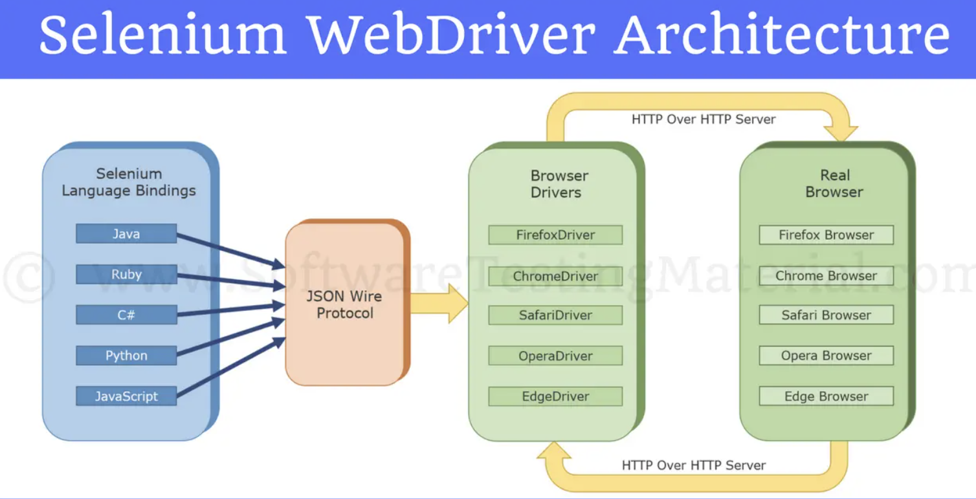

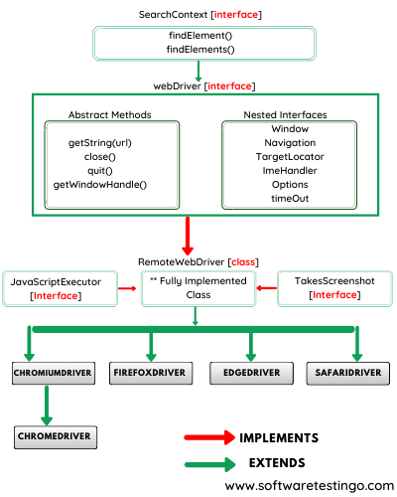

What is a locator and why do we need it?

In Selenium, locators are used to identify and locate web elements on a web page. It is used to identify an element uniquely so that it could be interacted with.

1. ID Locator: Syntax: driver.findElement(By.id("elementId"));
2. Class Name Locator: Syntax: driver.findElement(By.className("className"));
3. Name Locator: Syntax: driver.findElement(By.name("name"));
4. Tag Name Locator: Syntax: driver.findElement(By.tagName("tagName"));
5. Link Text Locator (for anchor tags): Syntax: driver.findElement(By.linkText("linkText"));
6. Partial Link Text Locator (for anchor tags): Syntax: driver.findElement(By.partialLinkText("partialLinkText"));
7. CSS Selector Locator: Syntax: driver.findElement(By.cssSelector("cssSelector"));
8. XPath Locator: Syntax: driver.findElement(By.xpath("xpath"));